Pheasant Run Homeowners Association
P.O. Box 4484 Topeka, KS 66601

Membership Meeting
April 12, 2021

Attendance: Board members -- Rosie, Ray, Lori, Becky, Karla, Ronda, and 18 additional Owners.

Agenda presented by Rosie for approval. Becky so moved, Lori seconded to accept agenda, and it was approved.

Ronda presented March 2021 minutes. Motion to approve as written by Jeff, seconded by Karla- approved.

Karla presented monthly financial report.

Old Business:

Rain Guards/Decks/ Patio’s:
On April 5th, Ronda Klein, Becky Carter and Rosie Cooper of the Board of Directors, did a walk through on all duplexes and the majority of the fourplexes. Our goal was to note how all decks, awning/patio covers, and patios are attached to the structure, as well as their current condition. What we found was alarming many without a doubt are attached and many are in need to repair and or replacement. Due to the sensitivity of this topic, we met in Executive Session on Tuesday April 6th. Discussion was lengthy with a big concern of how would an insurance claim be paid if our bylaws state no attachments, since insurance companies use the Declarations and Bylaws to determine what damages are covered by them.
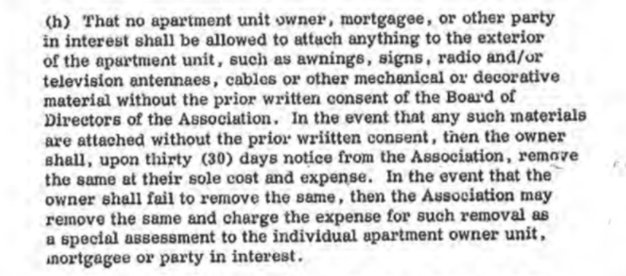

We agreed that we do not have the records to prove written consent. We agreed without knowledge to the exact time or process used to install patios, deck or awnings/patio covers we must deal with all 102 PR owners equally and justly. To protect the value and safety of all PR structures, the PR board of directors in line with Declaration of Condominiums article 13 (h) shall inspect any and all patios, decks, or awnings attached to a building at the HOA’s expense for the proper slope to mitigate water damage, sufficient guttering taking water away from the building, and no visible siding faults. Any home passing said inspection will be provided a letter of approval for said attached patio, deck, or awning by the board as referenced by Declaration of Condominiums paragraph 13(h). Any attached patio, deck, or awning not passing inspection the board will take it down from the existing unit. It was determined that to continue protecting the value and safety of all PR structures, Inspections will be done every two years starting in 2021.

We are currently in the process of contracting with an independent home inspector and have determined at least one board member will accompany the inspector to each member’s residence. We will notify all members of the exact date of inspection.

Safety:
A walk through of Pheasant Run was completed with Officer Caviness of TPD by Board Members Rosie Cooper, Becky Carter, Karla Jennings, and Lori Parks. Recommendations were mostly about making our community safer by increasing the lighting in dark areas and around carports and garages, which thieves usually target. Some of the suggested areas to increase lighting were: the fronts of all buildings, behind fourplexes & duplexes on car ports and lighting on any dark walking area for safety and as a crime deterrent. Additionally, increasing the use of NO TRESPASSING signage at entries, and lighting both areas that dead end at the creek (5801/5807 end and Tennis Court areas). Board Members are going to look into lighting options available to accommodate these recommendations.

Reserve Study Part 2:

The second part of the Reserve Study was presented to the members in attendance. At the conclusion of the presentation, members were asked in what priority they felt items in the Reserve Study should be handled from the knowledge that was acquired. The following list is the priorities, as seen by the membership in attendance:

- On-going maintenance
- Inspections
- Lighting
- Clean sewer lines
- No Trespassing Signs
- Inspections of Rain Guards/Patio’s/Decks
- Charging Station

May Meeting/Election:

The May Election meeting was discussed. Members wishing to run for the Board of Directors were solicited and instructed that applications to be on the ballot/proxy were due to the Board Secretary by April 15th. Jane Bicknell and Trish Turner volunteered to be Election Committee to count the votes for us again this year.

Announcement was made that Jeff Biggs was leaving Pheasant Run and would not be running for the Board this year. We applaud Jeff for his efforts and contributions to make Pheasant Run its best.

The meeting concluded at 8:08pm and was adjourned.

Ronda Klein
Secretary, PRHOA

